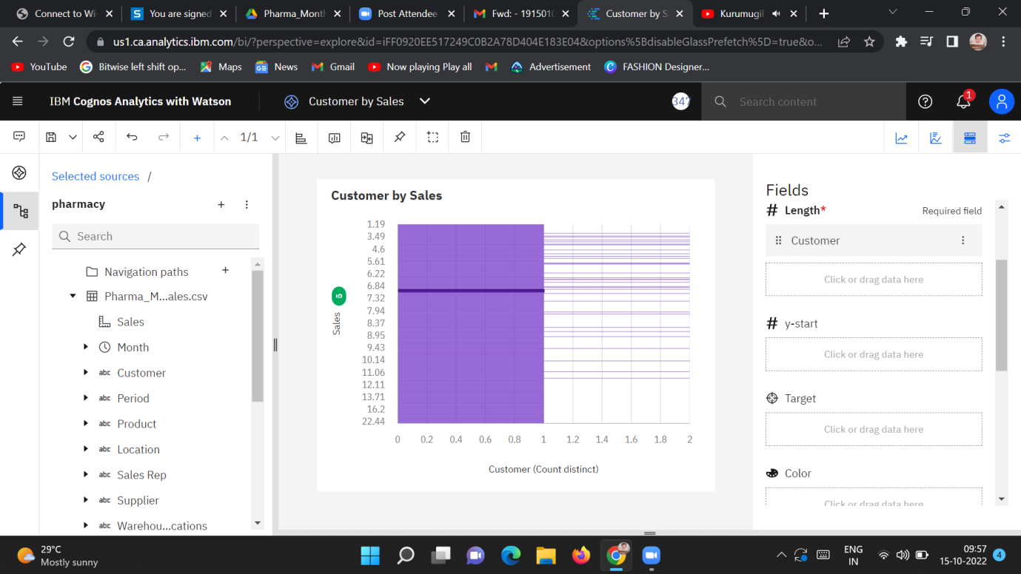

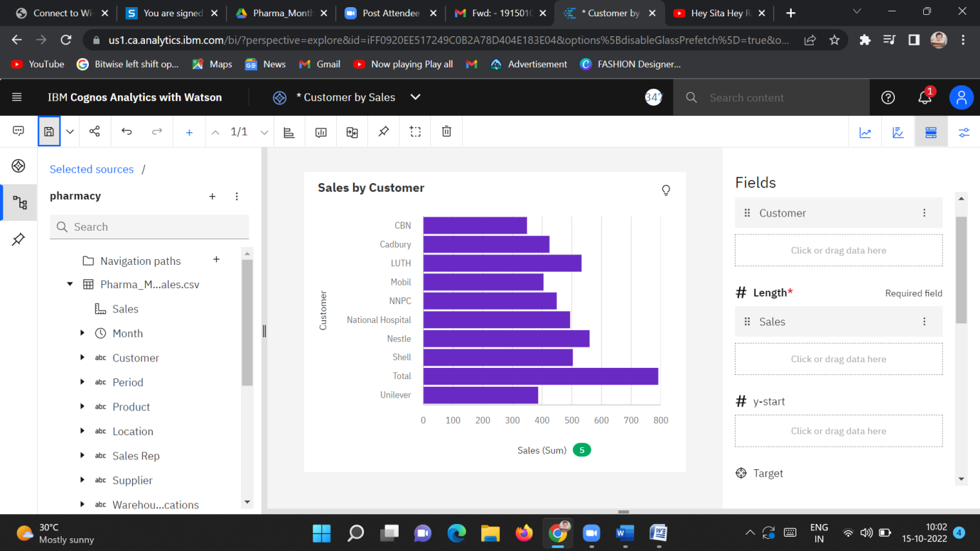

<https://us1.ca.analytics.ibm.com/bi/?perspective=explore&pathRef=.my_folders%2FCustomer%2Bby%2BSales&subView=model00000183d9decb40_00000000>

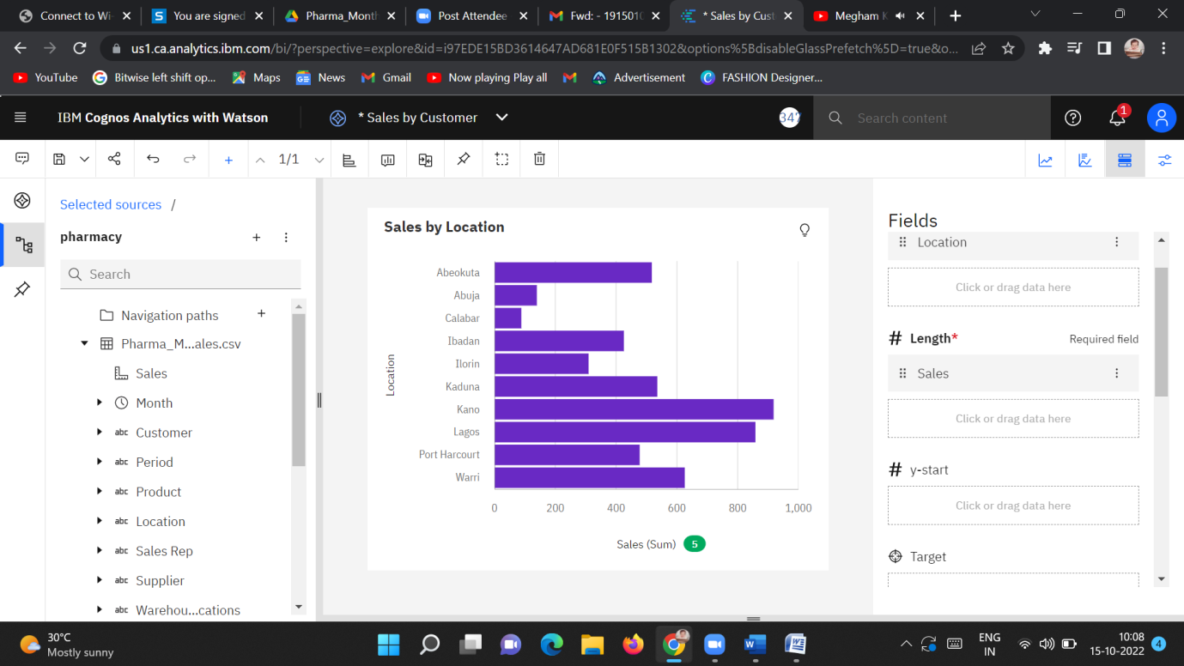

<https://us1.ca.analytics.ibm.com/bi/?perspective=explore&pathRef=.my_folders%2FSales%2Bby%2BCustomer&subView=model00000183d9decb40_00000000>

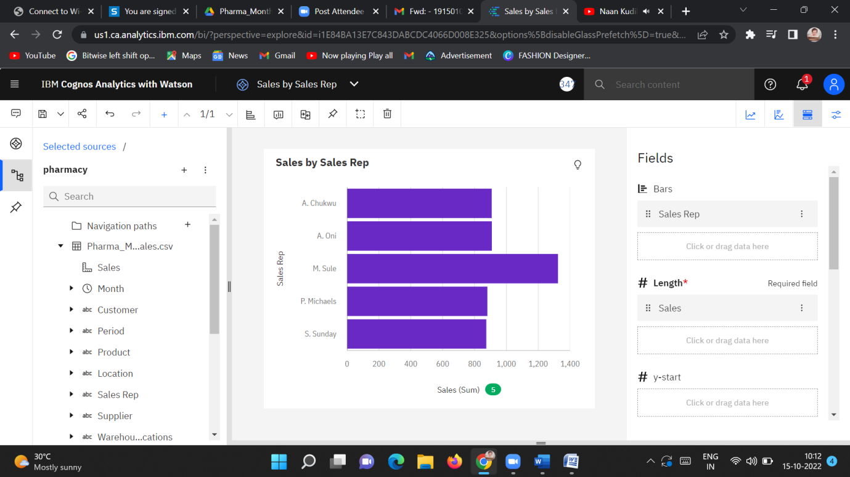

<https://us1.ca.analytics.ibm.com/bi/?perspective=explore&pathRef=.my_folders%2FSales%2Bby%2BSales%2BRep&subView=model00000183d9decb40_00000000>

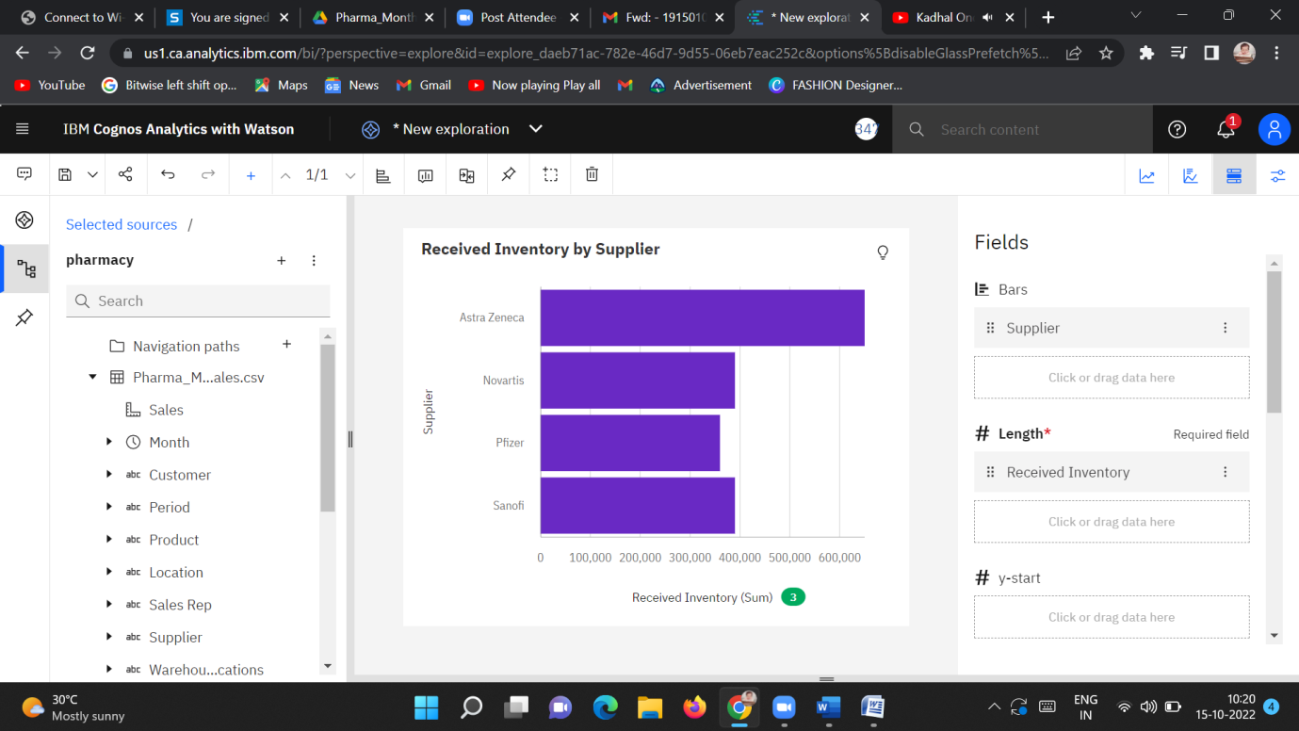

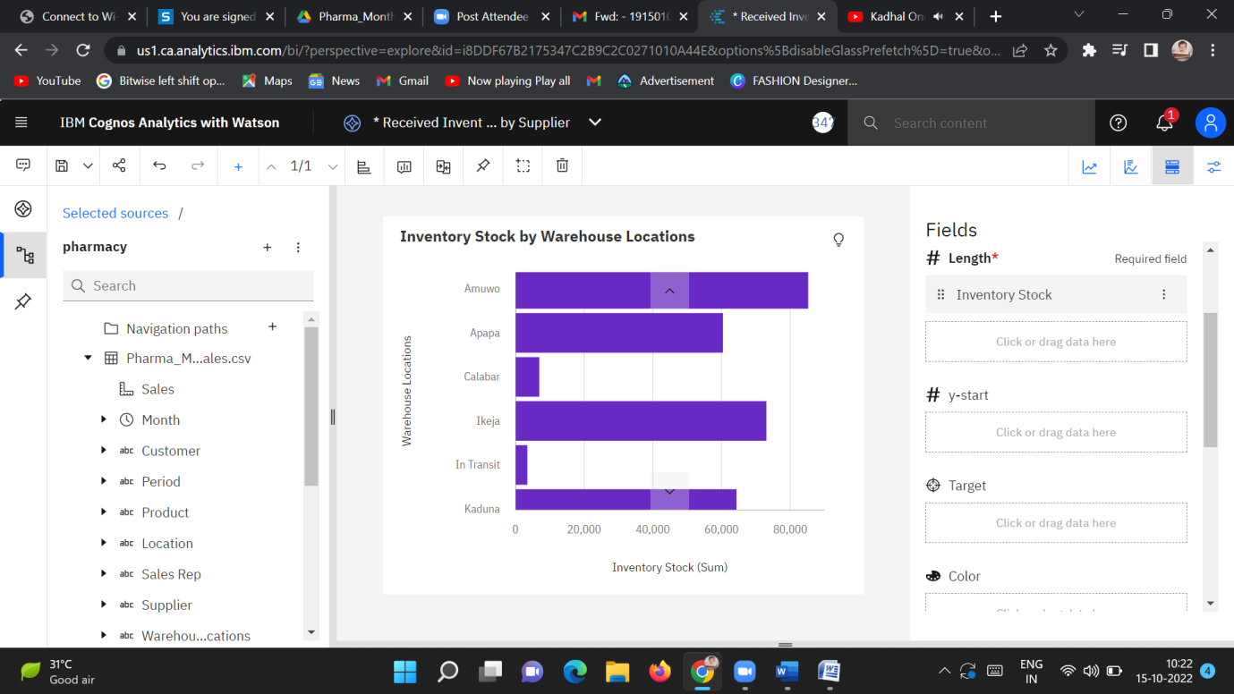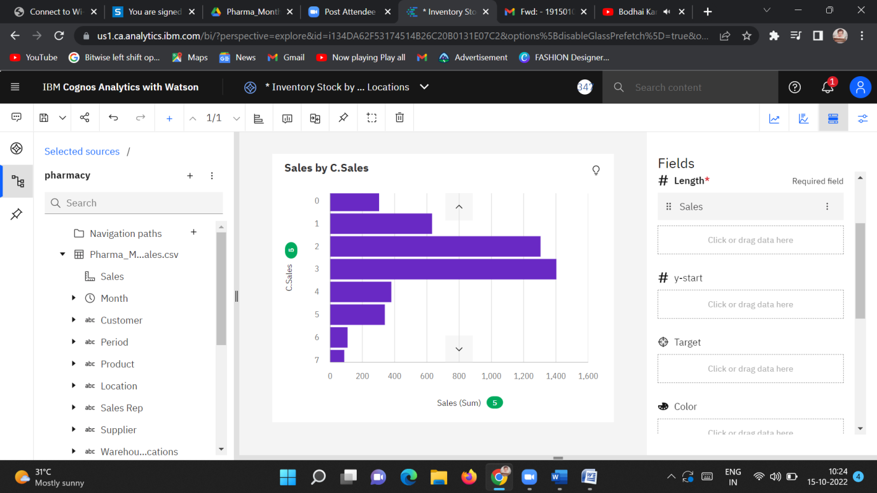

<https://us1.ca.analytics.ibm.com/bi/?perspective=explore&pathRef=.my_folders%2FSales%2Bby%2BC.Sales&subView=model00000183d9f8d281_00000000>

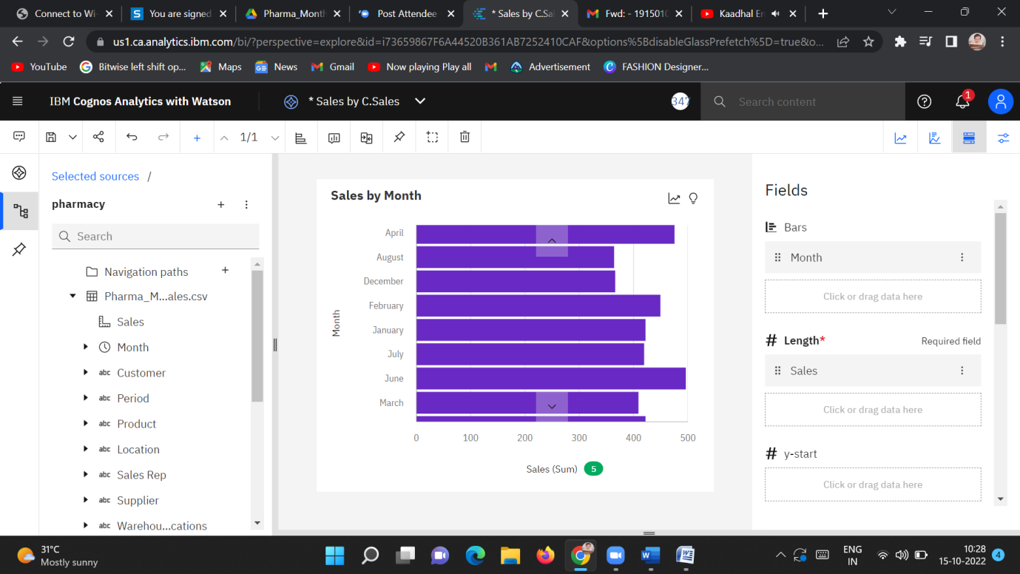

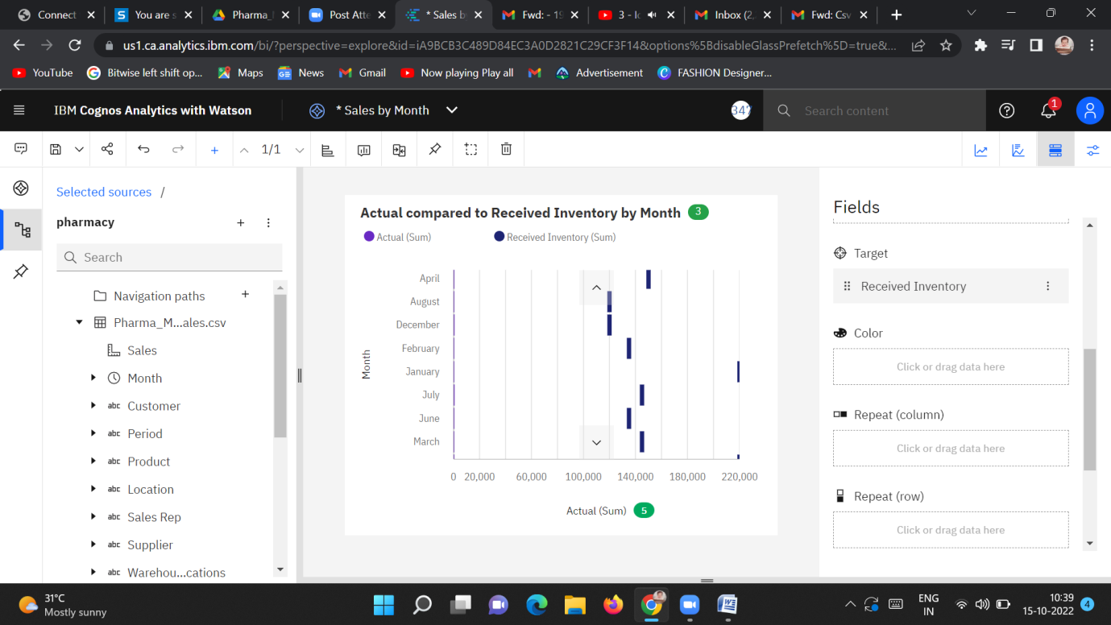

<https://us1.ca.analytics.ibm.com/bi/?perspective=explore&pathRef=.my_folders%2FActual%2Bcompared%2Bto%2BReceived%2BInventory%2Bby%2BMonth&subView=model00000183d9f8d281_00000000>

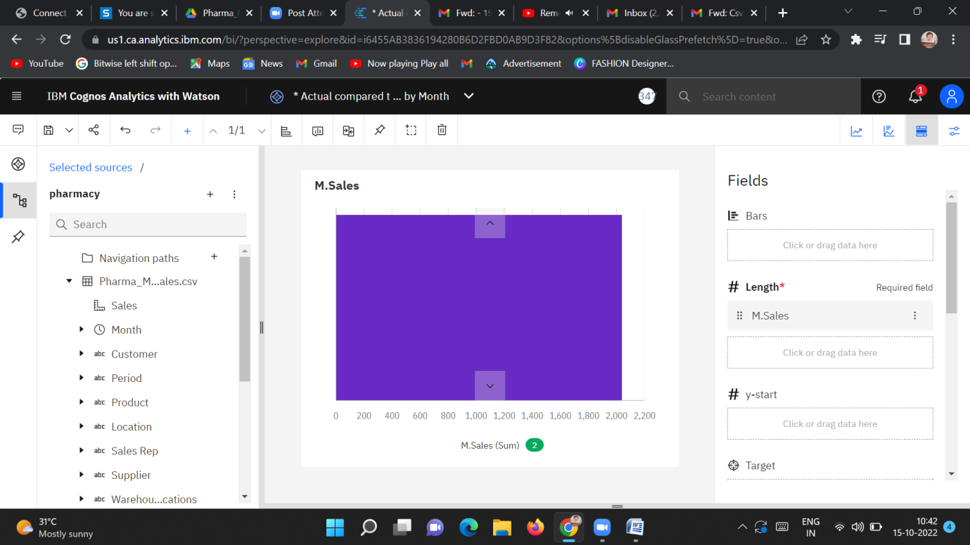

<https://us1.ca.analytics.ibm.com/bi/?perspective=explore&pathRef=.my_folders%2FM.Sales&subView=model00000183d9f8d281_00000000>